Activity | Data Type
Number of beatings from Wife | discrete
Results of rolling a dice | discrete
Weight of a person | continues
Weight of Gold | continues
Distance between two places | continues
Length of a leaf | continues
Dog's weight | continues
Blue Color | discrete
Number of kids | discrete
Number of tickets in Indian railways | discrete
Number of times married | discrete
Gender (Male or Female) | discrete
Q1) Identify the Data type for the Following:

Q2) Identify the Data types, which were among the following
Nominal, Ordinal, Interval, Ratio.
Data | Data Type
Gender | Nominal
High School Class Ranking | Ordinal
Celsius Temperature | Interval
Weight | Ration
Hair Color | Nominal
Socioeconomic Status | Ordinal
Fahrenheit Temperature | Interval
Height | Ration
Type of living accommodation | Nominal
Level of Agreement | Ordinal
IQ (Intelligence Scale) | Interval
Sales Figures | Ration
Blood Group | Nominal
Time Of Day | Interval
Time on a Clock with Hands | Interval
Number of Children | Ration
Religious Preference | Nominal
Barometer Pressure | Interval
SAT Scores | Interval
Years of Education | Ration

Q3) Three Coins are tossed, find the probability that two heads and one tail are obtained?

Total outcome = {HHH,TTT, HTT, THT,TTH, THH, HTH, HHT}
getting two head and one tail { THH, HTH, HHT}
Answer: 3/8

Q4) Two Dice are rolled, find the probability that sum is

- Equal to 1 (Yes)
- Less than or equal to 4
- Sum is divisible by 2 and 3

Q5) A bag contains 2 red, 3 green and 2 blue balls. Two balls are drawn at random. What is the probability that none of the balls drawn is blue?

Probability of draw 2 ball from 7 ball = 7c2
probability of draw not from blue = 5c2
(5c2) (7c2) = 10/21

Q6) Calculate the Expected number of candies for a randomly selected child
Below are the probabilities of count of candies for children (ignoring the nature of the child-Generalized view)
CHILD | Candies count | Probability
A | 1 | 0.015
B | 4 | 0.20
C | 3 | 0.65
D | 5 | 0.005
E | 6 | 0.01
F | 2 | 0.120
Child A – probability of having 1 candy = 0.015.
Child B – probability of having 4 candies = 0.20
= 1 * 0.015 + 4*0.20 + 3 *0.65 + 5*0.005 + 6 *0.01 + 2 * 0.12
= 0.015 + 0.8 + 1.95 + 0.025 + 0.06 + 0.24
= 3.090

Ans = 3.09
Use Q7.csv file
Q7) Calculate Mean, Median, Mode, Variance, Standard Deviation, Range & comment about the values / draw inferences, for the given dataset
- For Points,Score,Weigh>
Find Mean, Median, Mode, Variance, Standard Deviation, and Range and also Comment about the values/ Draw some inferences.
Ans :
Point Score Weight

mean 3.567 3.218 17.849
median 3.695 3.325 17.710
mode 3.07,3.92 3.44 17.02,18.90
std 0.535 0.979 1.187
variance 0.277 0.928 3.094
range 2.76-4.93 1.513-5.424 14.5-22.9
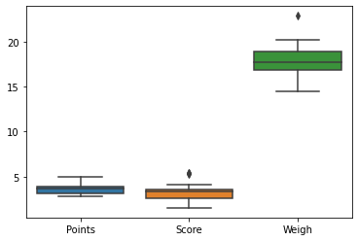

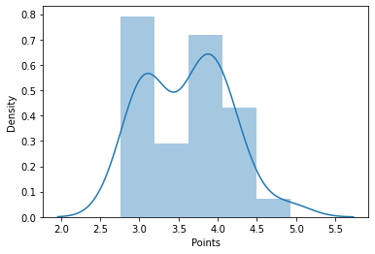
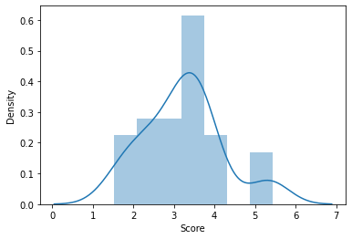
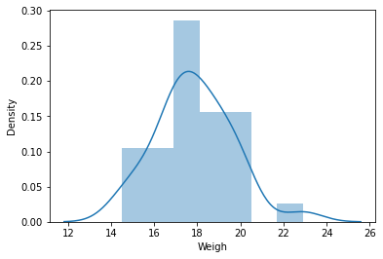

Q8) Calculate Expected Value for the problem below
- The weights (X) of patients at a clinic (in pounds), are
108, 110, 123, 134, 135, 145, 167, 187, 199
Assume one of the patients is chosen at random. What is the Expected Value of the Weight of that patient?
= (1/9) ( 108 + 110 + 123 + 134 + 135 + 145 + 167 + 187 + 199)
= (1/9) ( 1308)
= 145.33
Expected Value of the Weight of that patient = 145.33

Q9) Calculate Skewness, Kurtosis & draw inferences on the following data
Cars speed and distance
Use Q9_a.csv
skew kurtosis
speed -0.117510 -0.508994
distance 0.806895 0.405053
DIAGRAM
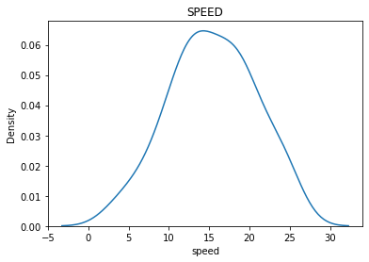

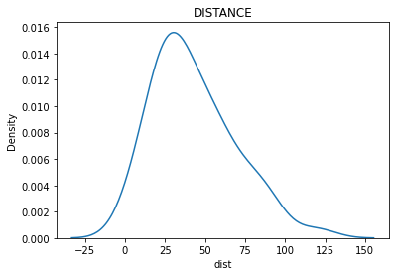
SP and Weight(WT)
Use Q9_b.csv
skew kurtosis
SPEED 1.611450 2.977329
WEIGHT -0.614753 0.950291
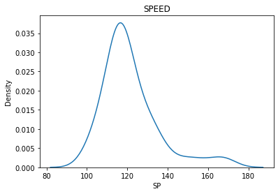

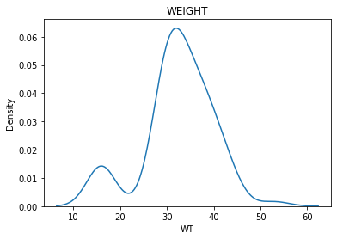
Q10) Draw inferences about the following boxplot & histogram
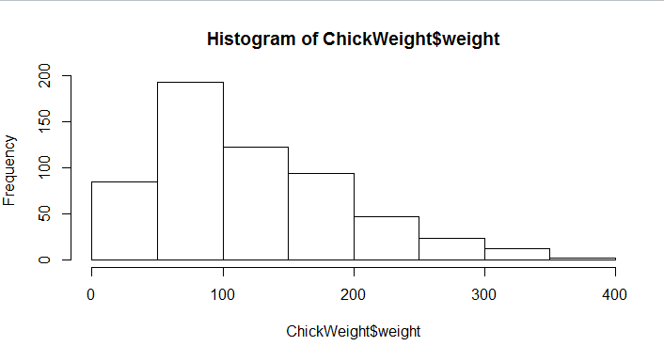

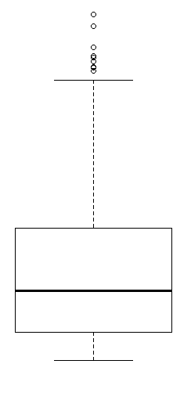

Q11) Suppose we want to estimate the average weight of an adult male in Mexico. We draw a random sample of 2,000 men from a population of 3,000,000 men and weigh them. We find that the average person in our sample weighs 200 pounds, and the standard deviation of the sample is 30 pounds. Calculate 94%,98%,96% confidence interval?

At 94% confidence interval [198.73833, 201.26167]
At 98% confidence interval [198.43944, 201.56056]
At 96% confidence interval [198.6223, 201.3777]

Q12) Below are the scores obtained by a student in tests
34,36,36,38,38,39,39,40,40,41,41,41,41,42,42,45,49,56
- Find mean, median, variance, standard deviation.
- What can we say about the student marks?

1)
Mean : 41.0
Median : 40.5
Variance : 24.11111111111111
Standard Deviation : 4.910306620885412

2)

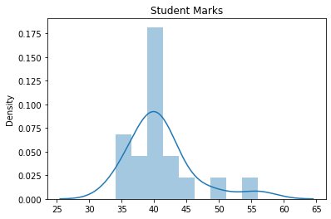

The majority student scored between 35 – 45 marks
It’s little bit right Skewed

Q13) What is the nature of skewness when mean, median of data are equal?
It is a Normalized Data
Q14) What is the nature of skewness when mean > median ?
Data is right skewed
Q15) What is the nature of skewness when median > mean?
Data is left skewed
Q16) What does positive kurtosis value indicates for a data ?
Positive kurtosis : thinner peak and wider tails
Q17) What does negative kurtosis value indicates for a data?
Negative Kurtosis : wider peak and thinner tails
Q18) Answer the below questions using the below boxplot visualization.
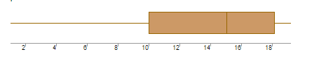
What can we say about the distribution of the data?
It dos not follow normal distribution
What is nature of skewness of the data?
Left skewed
What will be the IQR of the data (approximately)?
10 - 18

Q19) Comment on the below Boxplot visualizations?
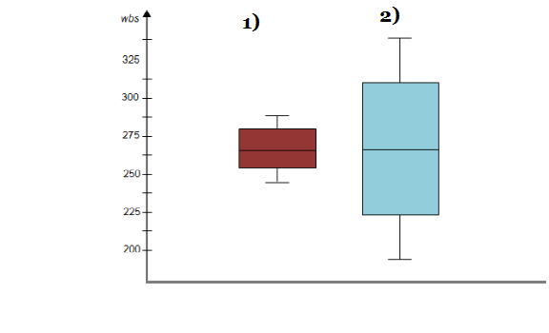
Draw an Inference from the distribution of data for Boxplot 1 with respect Boxplot 2.
Q 20) Calculate probability from the given dataset for the below cases

Data _set: Cars.csv
Calculate the probability of MPG of Cars for the below cases.
MPG <- Cars$MPG
  - P(MPG>38)
0.3475939251582705

  - P(MPG<40)
0.7293498762151616

c. P (20<MPG<50)
0.013116469610523339

Q 21) Check whether the data follows normal distribution
- Check whether the MPG of Cars follows Normal Distribution
Dataset: Cars.csv
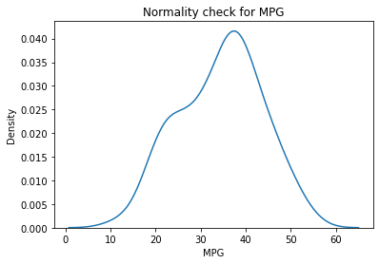
In cars data MPG is little bit left skewed

- Check Whether the Adipose Tissue (AT) and Waist Circumference(Waist) from wc-at data set follows Normal Distribution
Dataset: wc-at.csv
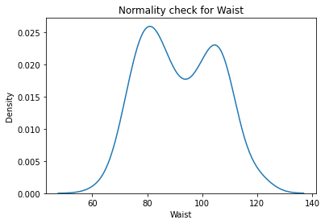

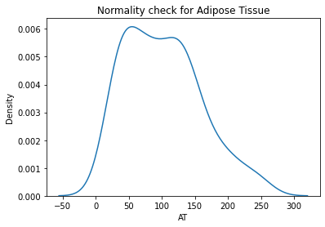
Q 22) Calculate the Z scores of 90% confidence interval,94% confidence interval, 60% confidence interval

Z-score at 90% confidence = 1.644854
Z-score at 94% confidence = 1.880794
Z-score at 60% confidence = 0.841621
Q 23) Calculate the t scores of 95% confidence interval, 96% confidence interval, 99% confidence interval for sample size of 25
T-score of 95% confidence interval = 2.0638985616280205
T-score of 96% confidence interval = 2.1715446760080677
T-score of 99% confidence interval = 2.796939504772804

Q 24) A Government company claims that an average light bulb lasts 270 days. A researcher randomly selects 18 bulbs for testing. The sampled bulbs last an average of 260 days, with a standard deviation of 90 days. If the CEO's claim were true, what is the probability that 18 randomly selected bulbs would have an average life of no more than 260 days
Hint:
rcode → pt(tscore,df)
df → degrees of freedom
Answer)
T-score
-0.4714045207910317
The cumulative probability: 0.32167 .Hence, if the true bulb life were 270 days, there is a 32.1% chance that the average bulb life for 18 randomly selected bulb would be less than or equal to 260 days

